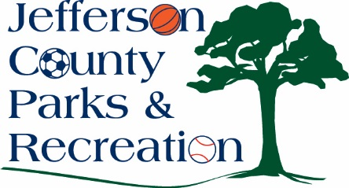
BOARD MEETING MINUTES
MAY 16, 2018
7:00 P.M.

Attendance: Hill, Jacobs, Lee, McIntyre, Manuel, Mountz, Neal
Absent: Hudson, Marshall, Milbourne, Pierson, Skinner, Taylor

Public Comment: Metina Bognwinia and John Thorne talking about improving our current volleyball courts and possibly adding more at our parks.

Motion to approve minutes by Manuel. APPROVED

Treasurer’s Report: no treasurer’s report this month

Director’s Report: Director Myers gave report.
Highlights include: General maintenance continue at all parks. Summer Programs will be starting soon and are almost full. There has been some damage to the parks from the recent storm and heavy rain that the maintenance department will be handling.
New Hire Approval: Manuel moved. Motion carried.

Committees:
Executive: did not meet

Finance: did not meet

Facilities/Land Acquisition: created a concept plan committee list

Operations: did not meet

Audit: did not meet

Unfinished Business: Motion to approve the bylaw changes to include the operations committee final reading by Mountz. Jacobs made the motion. APPROVED

Old Business:
- Update, discussion and possible action on bids and final plans for the Amphitheatre Phase 1 construction project at Sam Michael’s park.
Hill reported that he has reviewed the contract and has reduced the cost to $508,000 with maybe more reductions to follow. Terri Burhans, Park staff, has created a timeline for the development of the Amphitheater.

New Business:
- Discussion and possible action on reggae festival to be held on September 22 at Sam Michaels Park. Request to sell Beer/wine at the event.
Chris Grant with C & T Jerk who will be in charge of the event spoke to the commission about this event. Motion was made by Hill to approve the sale of beer/wine at the festival. APPROVED.

- Discussion and possible action on renewing the MOU with JC Historic Landmarks Commission for Peter Burr Farm.
This item was postponed and differed to the Operations Committee.

Motion to adjourn at 8:51 p.m. by Lee.

