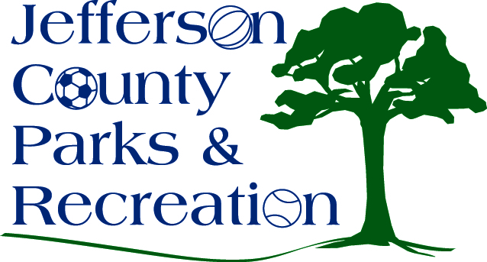
AGENDA
Jefferson County Parks & Recreation Commission
March 28, 2018
7:00 p.m.
Jefferson County Community Center

- Call to Order

- Roll Call

- Public Comment

- Approval of Minutes

- Treasurer’s Report

- Director’s Report

- Standing Committee Reports
      - Executive
      - Finance
      - Facilities/Land Acquisition
      - Operations
      - Audit

- Unfinished Business
  - Bylaw changes to include the operations committee-second reading.

- Old Business

- New Business
  - Discussion and possible action on awarding bid for the Amphitheatre Phase I construction project.
  - Discussion and possible action on resolution to apply for a Land and Water Conservation Fund Grant and a WV Cultural Resource Capital Resource Grant for the amphitheater Phase II development.

