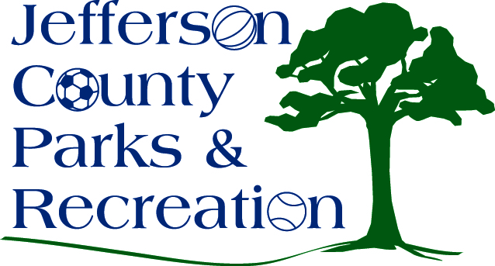
AGENDA
Jefferson County Parks & Recreation Commission
April 19, 2017
7:00 p.m.
Jefferson County Community Center

- Call to Order

- Roll Call

- Public Comment

  - Presentation: Matt Pennington, Region IV; Presentation on National Fish and Wildlife Grant Opportunity

- Approval of Minutes

- Treasurer’s Report

- Director’s Report

- Standing Committee Reports

      - Executive
      - Finance
      - Facilities/Land Acquisition
      - Fundraising
      - Audit

- Unfinished Business
  - Discussion and possible action to start the process to dissolve the fundraising committee. Third Reading

- Old Business

- New Business

  - Discussion and possible action on relocating the dog park within Sam Michaels Park and constructing a new dog park at James Hite Park.
  - Discussion and possible action on special events/mass gathering policy
  - Discussion and possible action on MOU with Jefferson County Historic Landmarks Commission
  - Discussion and possible action on closure of Bingo and Raffle Accounts.
  - Discussion and possible action National Fish and Wildlife Grant

