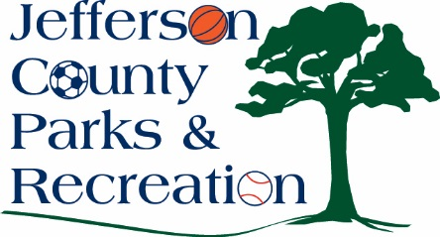
BOARD MEETING MINUTES
APRIL 18, 2018
7:00 P.M.

Attendance: Hill, Hudson, Jacobs, Lee, McIntyre, Marshall, Manuel
Absent: Milbourne, Neal, Pierson, Taylor

Public Comment: None

Motion to approve minutes by Manuel. APPROVED

Treasurer’s Report: Treasurer Hill gave report of finances. Motion to approved treasurer’s report by Manuel. APPROVED

Director’s Report: Director Myers gave report.
Highlights include: April 1, 2018, all parks are open to vehicular traffic, pavilions have been installed at James Hite Park. Spring programs are underway at the Community Center, and camping will begin May 5th at Moulton Park.
New Hires Approval: Manuel moved. Motion carried.

Committees:
Executive: met April 9th to discuss the bid for the Amphitheatre.

Finance: did not meet

Facilities/Land Acquisition: discussed dog park at James Hite Park.

Operations: did not meet.

Audit: did not meet but the audit is finished.

Unfinished Business: Director Myers read the second reading of the Bylaw changes.

New Business:
- Discussion and possible action on awarding bid for the Amphitheatre Phase I construction project.
Motion was made by Manuel to go into Executive Session at 8:16 p.m. to discuss the financial negation for the Amphitheatre which should not be made public at this time. Marshall made the motion for the Board to come out of Executive Session at 8:40. Motion by Hill to enter into negations with Minghini’s for the purpose of finalizing the scope and price not to exceed $515,500 with a goal to achieve a cost reduction between $30,000 to $40,000. Motion approved.

- Discussion and possible action on amending the concept plan at James Hite Park to construct a larger dog park.
Director Myers showed a proposed map with a small and large dog park at James Hite Park. The original master plan for James Hite Park did not have plans for a dog park but for mini golf. After discussion by the board the motion was made by Manuel to appeal the proposal subject to future finance and make the announcement on the Jefferson County Parks and Recreation face book page and website that we are proposing to extend the dog park what was originally mini golf. Motion approved.

- Discussion and possible action on awarding bid for the updated to the Sam Michael’s Park concept plan.
A Selection Committee met on April 16th with the 4 companies that were bidding on the Sam Michael’s Park concept plan. Based on conversation and rating the 4 companies a recommendation was made by the committee to award the contract to Michael Baker Intl. Lee made a motion to award Michael Baker Intl. the contract for Sam Michael’s Park Concept Plan. Motion approved.

Motion to adjourn at 8:51 p.m. by Lee.

