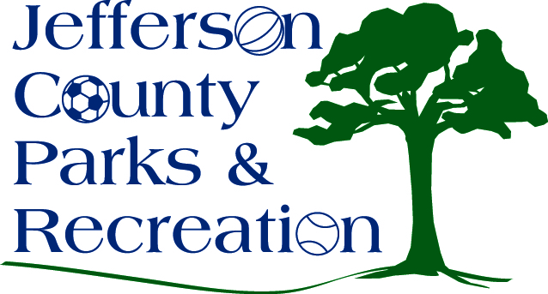
AGENDA
Jefferson County Parks & Recreation Commission
June 15, 2016
7:00 p.m.
Jefferson County Community Center

- Call to Order

- Roll Call

- Public Comment

- Approval of Minutes

- Treasurer’s Report

- Director’s Report

- Standing Committee Reports

      - Executive
      - Finance
      - Facilities/Land Acquisition
      - Fundraising
      - Audit

- Unfinished Business

- Old Business

- New Business
  - Discussion and possible action on personnel decisions (executive session)
  - Discussion and possible action on Participant Discipline Policy
  - Discussion and possible action on a Parks and Recreation Levy
  - Discussion and possible action on a Social Media Policy
  - Discussion and possible action on a field maintenance policy
  - Discussion and possible action on FY16/17 budget

