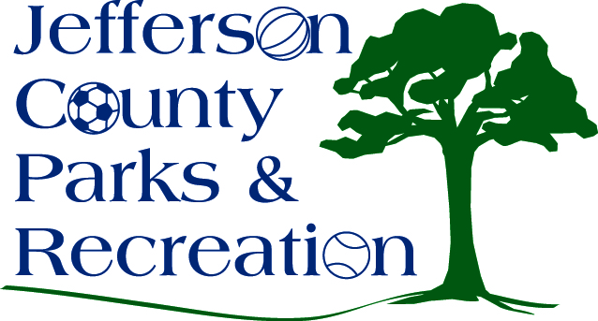
AGENDA
Jefferson County Parks & Recreation Commission
April 17, 2019
7:00 p.m.
Jefferson County Community Center

- Call to Order

- Roll Call

- Public Comment

- Approval of Minutes

- Treasurer’s Report

- Director’s Report

- Standing Committee Reports
      - Executive
      - Finance
      - Infrastructure
      - Operations
      - Audit

- Unfinished Business

- Old Business

  - Discussion and possible action on parks and recreation program management plan.
  - Discussion and possible action on installing a plaque in the Jefferson County Community Center, dedicating it to past board members and officials instrumental in building the facility.

- New Business
  - Discussion and possible action to change the meeting date from May 15, 2019 to May 22, 2019.
  - Discussion and possible action to charge an admission or parking fee for 2019 fireworks event on June 29 due to low sponsorships for the event.
  - Discussion and possible action on accepting corporate sponsorships for events and facilities.
  - Discussion and possible action to allow Bakerton Fire Department to sell tips at the Soaring into Summer Events.

- Adjournment

