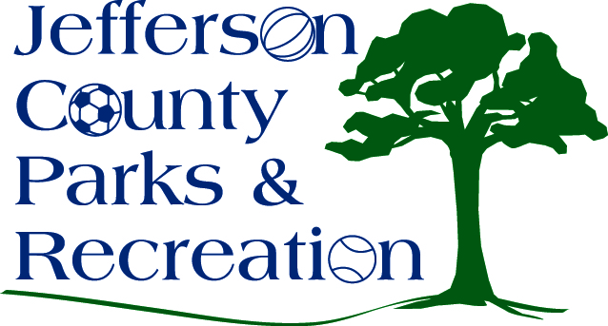
AGENDA
Jefferson County Parks & Recreation Commission
November 16, 2016
7:00 p.m.
Jefferson County Community Center

- Call to Order

- Roll Call

- Public Comment

- Approval of Minutes

- Treasurer’s Report

- Director’s Report

- Standing Committee Reports

      - Executive
      - Finance
      - Facilities/Land Acquisition
      - Fundraising
      - Audit

- Unfinished Business
  - Discussion and possible action on sale/lease of Bolivar Nature Park.

- Old Business
1. Discussion and possible action of the Final draft of the 10-Year Master Plan.

- New Business
  - Discussion and possible action on full-time staff salaries and possible adjustments.
  - Discussion and possible action on overtime and comp time policy.
  - Discussion and possible action on fireworks contract for 2017.
  - Discussion and possible action on 2017/2018 CIP.

