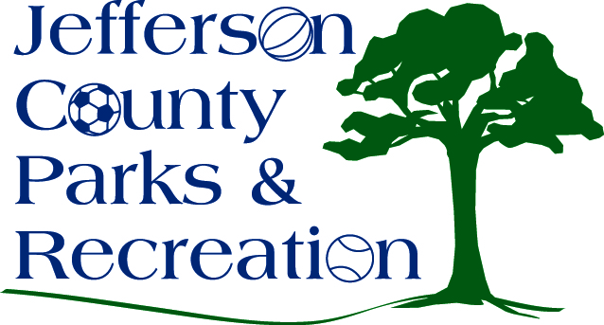
AGENDA
Jefferson County Parks & Recreation Commission
Special Meeting
May 28, 2020
7:00 p.m.

- Call to Order

- Roll Call

- New Business

  - Updates, discussion and possible action on updated park/personnel policies regarding COVID-19 including re-opening of the Jefferson County Community Center and staffing.
  - Updates and possible action on financial implemtations of COVID-19 and future actions.

- Adjournment

