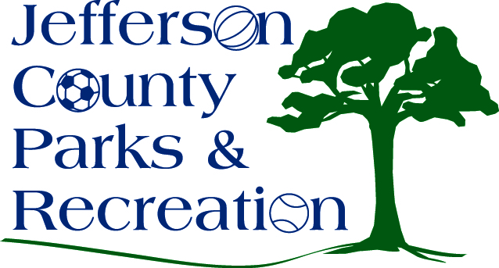
AGENDA
Jefferson County Parks & Recreation Commission
Master Planning Sub-Committee Meeting
February 9, 2016
7:00 p.m.
Jefferson County Community Center

  - Discussion and review of Draft Master Plan

