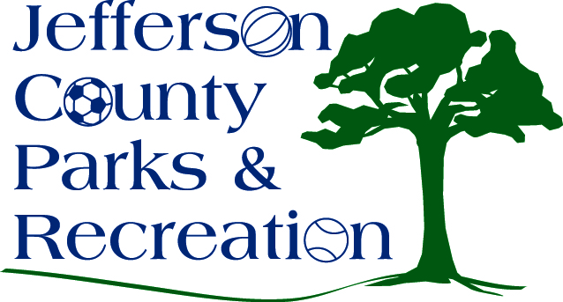
AGENDA
Jefferson County Parks & Recreation Commission
March 16, 2016
7:00 p.m.
Jefferson County Community Center

- Call to Order

- Roll Call

- Public Comment

- Approval of Minutes

- Treasurer’s Report

- Director’s Report

- Standing Committee Reports

      - Executive

      - Finance

      - Facilities/Land Acquisition

      - Fundraising

      - Audit

- Unfinished Business

- Old Business

  - Discussion and possible action on fireworks contract

- New Business

