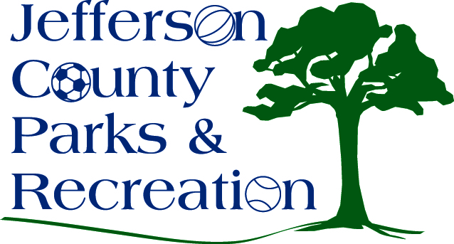
AGENDA
Jefferson County Parks & Recreation Commission
April 20, 2016
7:00 p.m.
Jefferson County Community Center

- Call to Order

- Roll Call

- Public Comment

- Approval of Minutes

- Treasurer’s Report

- Director’s Report

- Standing Committee Reports

      - Executive
      - Finance
      - Facilities/Land Acquisition
      - Fundraising
      - Audit

- Unfinished Business

- Old Business
  - Update, discussion and possible action on fireworks contract (possible executive session)
  - Update, discussion and possible action on Park Manger and Facilities Coordinator Positions (possible executive session).

- New Business
  - Discussion and possible action to move forward with MOU with Jefferson County Schools and incorporate Adult and Community Education Programs
  - Discussion and possible action on future capital projects and funding sources (PM)
  - Discussion and possible action on increasing the set aside for Hotel/Motel Tax for future FY budgets.

