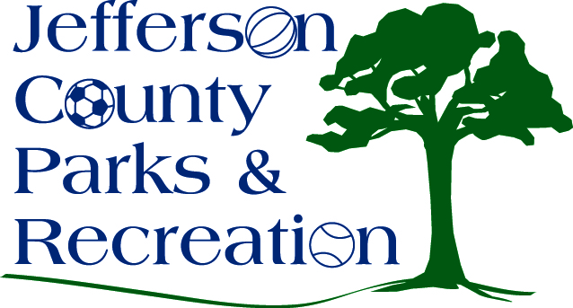
SPECIAL MEETING AGENDA
Jefferson County Parks & Recreation Commission
April 28, 2016
6:00 p.m.
Jefferson County Community Center

- Call to Order

- Roll Call

- New Business
  - Discussion and possible action on approval of MOU with Town and Trail Alliance of Harpers Ferry-Bolivar to allow seasonal long distance camping at Bolivar Nature Park.

