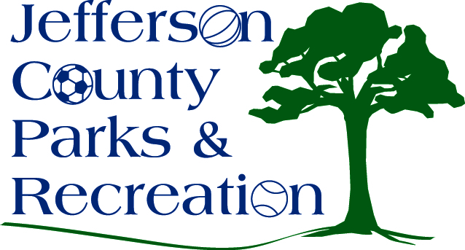
AGENDA
Jefferson County Parks & Recreation Commission
July 20, 2016
7:00 p.m.
Jefferson County Community Center

- Call to Order

- Roll Call

- Public Comment

- Approval of Minutes

- Treasurer’s Report

- Director’s Report

- Standing Committee Reports

      - Executive
      - Finance
      - Facilities/Land Acquisition
      - Fundraising
      - Audit

- Unfinished Business
  - Discussion and possible action on personnel decisions (executive session)
  - Discussion and possible action on Participant Discipline Policy
  - Discussion and possible action on a Social Media Comments Policy
  - Discussion and possible action on a field maintenance policy
  - Discussion and possible action on FY16/17 budget

- Old Business

- New Business
  - Discussion and possible action on renewal of camping MOU with Harpers Ferry Town and Trail Alliance at Bolivar Nature Park.
  - Discussion and possible action on election of Treasurer
  - Discussion and possible action on MOU with Jefferson County Schools

