Minutes of the regular meeting of the Jefferson County Parks and Recreation Commission

July 20, 2016

I. Call to order 7:05 pm.

II. Roll Call

Commissioners:, Ann Mountz, Heather McIntyre, Toni Milbourne, Dan McVicar, , Jimmy Pierson, Elaine Pasternak

Staff: Jennifer Myers

Guests: Dale Manual

Commissioners Absent: David Hill, Jim Lee, Gene Taylor, Ranale Jones

III. Public comment

Elaine introduced herself. Milbourne reported that commissioner Sarah Smith resigned her position. The CC is accepting applications.

IV Approval of Minutes

Motion by McIntyre to approve the minutes for the June 15 meeting after correction of the date on the printed version. Unanimously approved.

V Treasurer’s Report

Myers reported the results of the audit. Simple findings are being discussed with the accountant. She reported nearly $50,000 in the impact fund and normalization of the allocation targets. Operating cash is approximately $150,000. She offered several action items including deferred payroll for summer camps, firework for 2017, and maintenance withheld from FY2016 including repair of the walking trail, electric upgrade at Leetown, a mower, and office furniture that are already ordered.

VI Director’s Report

Jefferson County Parks & Recreation Commission
Monthly Director’s Report
July 20, 2016
Jennifer Myers, Director

Below is a snapshot of activities, parks, and projects currently underway in the parks. Maintenance staff works diligently to ensure the parks are safe and well-maintained. Our maintenance staff has been working to paint all fences in the parks as well as replace/repair fencing over the past month.

- Parks/Facilities Report:
- Bolivar Nature Park
  - Camping for AT hikers began in mid-May. The MOU with Harpers Ferry Town and Trail Alliance ends as of August 1, 2016.
  - New park sign has been ordered and will be installed.
  - New trail signage has been installed on the nature trail.

- James Hite Park
  - Final payment was made to Gantts.
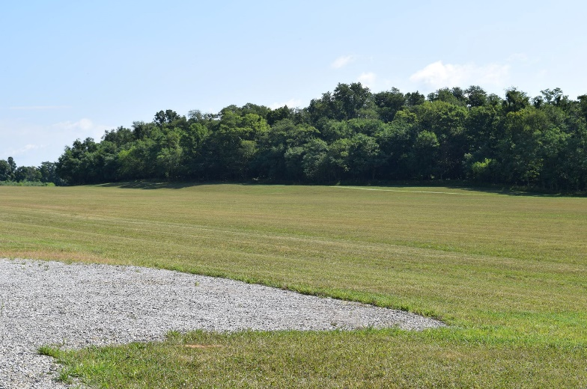
  - Trail is being used daily.
  - The Storm Water Retention ponds are holding water. Permanent No swimming or wading signs are being made and will be installed.
  - JCYFL started practices the week of July 18th
  - JCYSL will have field day August 20th with practices beginning the August 22nd.
  - Ribbon Cutting/Dedication is planned for September 10th at 9:30 a.m.

- Jefferson County Community Center
  - Construction continues on the new office.

- Leetown Park
  - Field Maintenance
  - JCML will begin Fall Ball the first week of August.
  - Trees at Leetown are infected with Ash Bore-approximately 25 trees will need to be removed.

- Morgan’s Grove Park
  - General maintenance
  - EPIC and Tri-County Youth Soccer are both interested in booking dates for Fall Use. The soccer fields by the railroad tracks will be closed and not used this fall to help generate regrowth. Top fields will be rented.

- Mount Mission Park
  - New steel doors have been installed on the pavilion
  - Future spring Project-Removal of chain link fence and installation of split rail

- Moulton Park
  - Heavy use by boaters
  - Camping continues through September.

- Sam Michael’s Park
  - Mason Pavilion has been painted and updated to match the Veteran’s Pavilion.
  - Old fencing and plantings have been removed from around the Mason pavilion.
  - ADA accessible sidewalks will be installed this fall at the Mason Pavilion by Job Corps.
  - New steel picnic tables have arrived and are currently being assembled for the mason pavilion. They will be installed this fall after day camps are complete.
  - Balloon launches have been built at the mason pavilion and are now in use.
  - All buildings within the park have been painted to match the community center and pavilions. We are currently working with the Reserves to have their trailer painted as well.
  - Large trees at the park entrance have been taken down.

- South Jefferson Park
  - General Maintenance

- Damage Report:
- None

- Equipment Report:
- None

- Personnel Update/New Hires:
  - None
  - In the process of hiring new staff to run adult and community education programs. Paperwork is currently being completed.

- Leave Request:
- David Kling: July 18-22
- Jennifer Myers: July 25-29 and August 12-19

- Report on Grant Projects:

- Awarded
  - Eastern Area Health and Education Grant-James Hite Park trail. $40,000. We have been reimbursed $20,000. The remainder of the grant will be paid out in May. A reminder has been sent.
  - LWCF in the amount of $99,000 was awarded for soccer fields at James Hite Park. Requested an extension until December 2016 that was approved by the National Park Service. The $10,000 balance left on the grant will be held until I file for completion. Leaving the grant open allows for potential funding.
  - Jefferson County Youth Board-$1000 for program supplies. $500 for youth scholarships.

- Pending
  - Application for LWCF in the amount of $62092 was submitted December 1, 2015. Project has been waitlisted. Received a call from the state asking for updated numbers and any additions to the grant as more funding is available
  - Elks Run Watershed Rain Garden Rebate Program- JCCC/Sam Michael’s Park-Postponed until Fall due to lack of funding.
  - Chesapeake Bay-$10,000 for James Hite Park

- Program Updates:
  - Summer camps are in full swing. Numbers have been strong this summer with a lot of full camps and waitlists. (see attached)

- Summer Movie Nights
  - Avengers was shown June 17 at Sam Michael’s Park
  - Minions was shown July 1st at Jefferson Memorial Park.
  - Star Wars was shown July 15
  - Zootopia will be shown at Blue Ridge Primary on July 22nd. Due to the projected attendance, the movie was moved from Mount Mission Park.
  - Aladdin is in August.
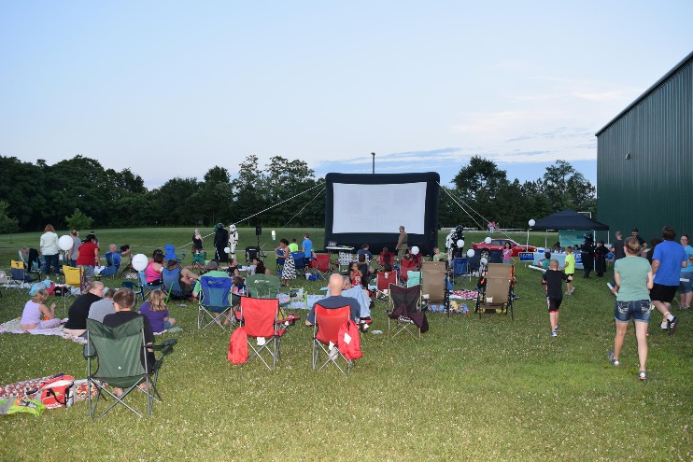

- Fireworks
  - Budget attached.
  - Event was well-attended and was well received. Traffic was a concern and we are working with the Sheriff’s Department to have a better game plan for next year.
  - RFP for Fireworks 2017 is out. Bids are due August 1st. (attached)
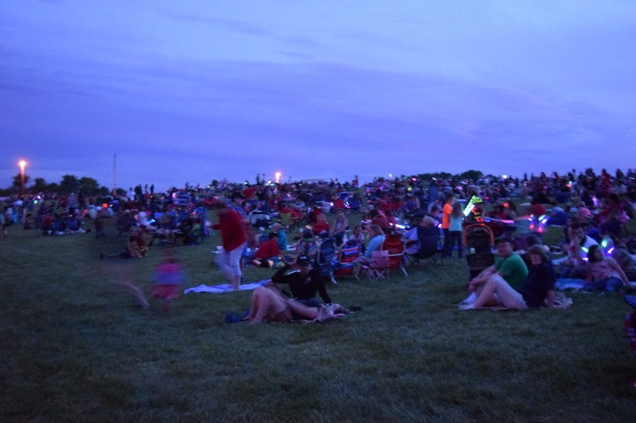

- Donations:
  - Fireworks donations continue to come in.
  - A letter will go out in early September to businesses listing opportunities for sponsorship for 2017. Letter will include movie nights, special events, fireworks, and banners.

- Other
  - Staff is currently working on the Fall 2016 Program Guide. 55 adult programming opportunities have been added as well as new youth programs. Staff is eliminating programs that do not have a large following and are not self-sufficient. Staff is also restricting programs, such as the teen dances, that have run for 10 years to better suit current needs of the county.

10. Communications
A. Master Plan Underway
a. A draft was sent to board members for review. Comments received have been sent to SGA.
b. A meeting will be scheduled to determine next steps and expectations for SGA.
d. Timeline is being pushed to September for a public hearing.

11. Trainings/Meetings

12. Future Needs from Board

VII Standing Committee Reports

Executive

Met to discuss, several items including additional positions, would like to add one based on the $15,000 from the school system for adult education programming. This would be a facility coordinator. This would be a programming position. The draft budget was discussed. In addition, we discussed a possible modification of the hand book policy on provision of benefits to part-time employees. Also discussed the need for lots of official policies for the department. Starters will be discipline, turf, social media. The draft school MOU was also discussed.

Finance

No meeting.

Facilities/Land Acquisition

McVicar reported that the committee discussed the use of Hite Park by the soccer league, the development of a turf management policy working toward $2,000/ac (best is $8,000). We also discussed the master plan draft, Dave Hill sent comments. There was substantial discussion of the use of James Hite by the football league. They want to begin practice. Myers will develop a contract that addresses maintenance and fees. On the land front we discussed the possible use of 56 ac of land along the stream that is associated with the Kodak site. The purchase is finished and the option is to deed the land to parks and rec. The civil war trust is buying it and it will be managed by Historic Landmarks, and deeded to Parks and Rec.

Fundraising

No meeting.

Audit

No meeting. This committee will be revamped.

VIII Unfinished Business

- Discussion and possible action on personnel decisions (possible executive session)

No update to the discussion at executive.

- Discussion and possible action on participant discipline policy

A draft policy was distributed. This is a modification of the policy reviewed at the executive committee.

Motion to approve the draft policy by Mountz. Approved unanimously.

- Discussion and possible action on a social media comments policy

Draft is being reviewed by the county attorney.

- Discussion and possible action on a field maintenance policy

Draft is under revision and will go back to facilities.

- Discussion and possible action on FY16/17 budget

The draft budget was distributed. The proposal included last year’s numbers and actuals. Mountz discussed some of the issues pointed out during the last discussion. There was substantial discussion about the utility of the new position and whether the money provided by the school board would be sufficient to support the programs currently planned under the adult ED banner.

Motion to approve the FY16/17 budget by Mountz. Approved unanimously.

IX Old Business

X New Business

- Discussion and possible action on Renewal of camping MOU with Harpers Ferry Town and Trail Alliance at Bolivar Nature Park.

Motion to not renew our MOU with the Harpers Ferry-Bolivar Historic Town Foundation regarding camping at the park. Approved unanimously.

- Discussion and possible action on Election of treasurer

The executive committee discussed this a bit and are hopeful that Dave Hill would take on the office.

Milbourne nominates Dave Hill as Treasurer. If he accepts, this will be addressed at the next meeting.

- Discussion and possible action on MOU with Jefferson County Schools

Myers presented the draft MOU with the school system.

Motion to approve the draft Schools MOU, pending approval by the county attorney, by Mountz. Approved unanimously.

XI Motion to Adjourn 8:57pm

