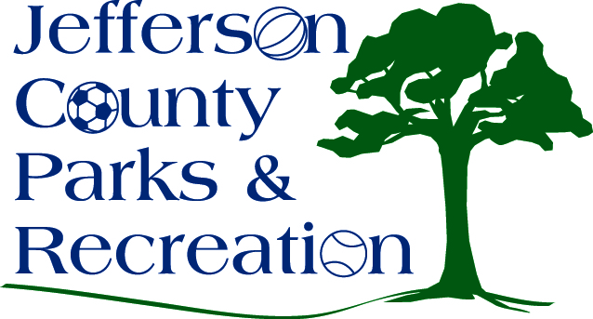
AGENDA
Jefferson County Parks & Recreation Commission
July 19, 2017
7:00 p.m.
Jefferson County Community Center

- Call to Order

- Roll Call

- Public Comment

- Approval of Minutes

- Treasurer’s Report

- Director’s Report

- Standing Committee Reports

      - Executive
      - Finance
      - Facilities/Land Acquisition
      - Fundraising
      - Audit

- Unfinished Business

- Old Business
  - Final Reading to dissolve the Fundraising Committee (A. Mountz)

- New Business
  - Discussion and possible action on Leetown Park softball fields/netting (D.Hill)
  - Discussion and possible action on approval of Flex/Comp-Time Policy
  - Discussion and possible action on capital projects and partnerships for FY 17/18
  - Discussion and possible action on craft beer festival

