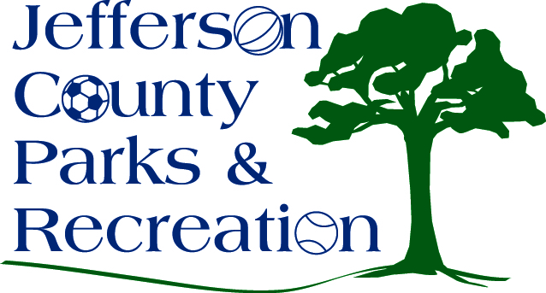
AGENDA
Jefferson County Parks & Recreation Commission
February 21, 2018
7:00 p.m.
Jefferson County Community Center

- Call to Order

- Roll Call

- Public Comment

- Approval of Minutes

- Treasurer’s Report

- Director’s Report

- Standing Committee Reports
      - Executive
      - Finance
      - Facilities/Land Acquisition
      - Operations
      - Audit

- Unfinished Business

  - Reading of bylaws to add the Operational Committee as an official committee of the board.

- Old Business

- New Business

  - Election of Officers

