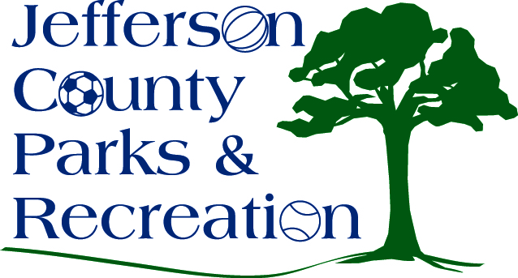
AGENDA
Jefferson County Parks & Recreation Commission
May 16, 2018
7:00 p.m.
Jefferson County Community Center

- Call to Order

- Roll Call

- Public Comment

- Approval of Minutes

- Treasurer’s Report

- Director’s Report

- Standing Committee Reports
      - Executive
      - Finance
      - Facilities/Land Acquisition
      - Operations
      - Audit

- Unfinished Business
  - Bylaw changes to include the operations committee-final reading.

- Old Business
  - Update, discussion and possible action on bids and final plans for the Amphitheatre Phase I construction project at Sam Michael’s Park.

- New Business
  - Discussion and possible action on reggae festival to be held on September 22nd at Sam Michael’s Park. Request to sell Beer/Wine at the event.
  - Discussion and possible action on renewing the MOU with JC Historic Landmarks Commission for Peter Burr Farm.

