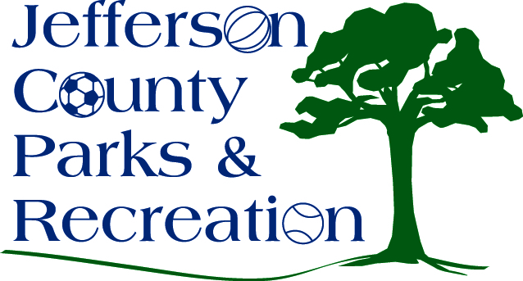
AGENDA
Jefferson County Parks & Recreation Commission
May 22, 2019
7:00 p.m.
Jefferson County Community Center

- Call to Order

- Roll Call

- Public Comment

  - Mike Glenn, former director of the USDA Fruit Research Station in Kearneysville to give a short presentation on Rockwool’s air pollution controls and permit. The purpose is to educate the board on the impact of the facility that is being built.

- Approval of Minutes

- Treasurer’s Report

- Director’s Report

- Standing Committee Reports
      - Executive
      - Finance
      - Infrastructure
      - Operations
      - Audit

- Unfinished Business

- Old Business
  - Discussion and possible action on parks and recreation program management plan (Milbourne)
  - Discussion and possible action on accepting corporate sponsorships for events and facilities.

- New Business
  - Discussion and possible action on the proposal that JCPR not accept sponsorships from Rockwool (Marshall)
  - Discussion and possible action on an MOU with the Town of Bolivar to provide maintenance at Bolivar Nature Park. (Milbourne)
- Adjournment

