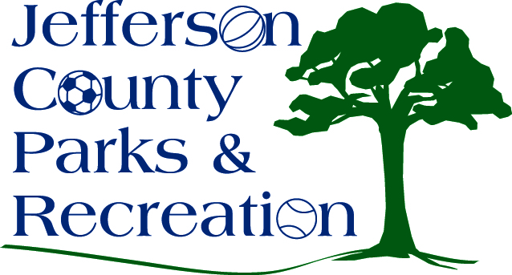
AGENDA
Jefferson County Parks & Recreation Commission
January 15, 2020
7:00 p.m.
Jefferson County Community Center

- Call to Order

- Roll Call

- Public Comment

- Approval of Minutes

- Treasurer’s Report

- Director’s Report

- Standing Committee Reports
      - Executive
      - Finance
      - Infrastructure
      - Operations
      - Audit

- Unfinished Business

- Old Business

- New Business

  - Discussion and possible action on land acquisition (Possible executive session).
  - Discussion and possible action on request to county commission for FY Budget 20/21

- Adjournment

