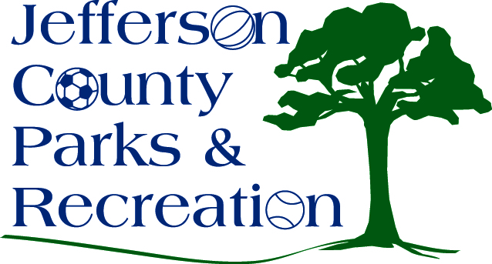
MINUTES
Jefferson County Parks & Recreation Commission
Special Meeting
December 16, 2020
7:00 p.m.
Zoom

- Call to Order: 7:04 p.m.

- Roll Call: Compton, Hill, Dingas, McIntyre, Milbourne, Mountz, Thompson

- New Business
  - Discussion and possible action on LWCF grant resolution in the amount of $156,000.
    - Mountz made motion to adopt the resolution for the LWCF grant. Approved
  - Discussion and possible action on MOU with WV Land Trust
    - No action taken
  - Discussion and possible action on Impact Fee Recalculation.
    - No action taken

- Adjourn: Mountz made motion to adjourn at 7:22pm. Motion passed.

