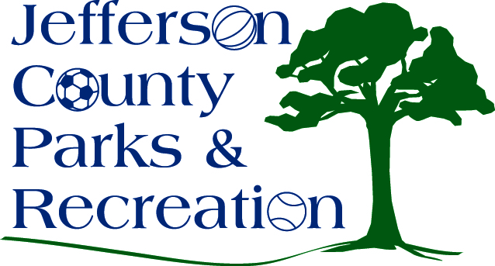
MINUTES
Jefferson County Parks & Recreation Commission
January 15, 2020
7:00 p.m.
Jefferson County Community Center

- Call to Order: 7:00 p.m.

- Roll Call; Manuel, Marshall, Milbourne, Mountz, McIntyre, Osantowaske, Taylor

BOD Absent: Dinges, Hill, Pierson, Skinner, Thompson

- Public Comment: none

- Approval of Minutes: Manuel made motion. Approved

- Treasurer’s Report: Marshall gave treasurer’s report in the absence of Hill.

- Director’s Report: Assistant Director Kling gave director’s report in the absence of Director Myers. All parks except the Community Center remains closed to vehicular traffic through April 1st. Winter programing is underway. Motion by Mountz was made to approve the new hires. Approved

- Standing Committee Reports
      - Executive: no
      - Finance: no
      - Infrastructure: Discussed potential properties for sale
      - Operations: met with Rodney Smith concerning Babe Ruth contract for 2020 and the volunteer Manuel
      - Audit: no

- Unfinished Business

- Old Business

- New Business

  - Discussion and possible action on land acquisition (Possible executive session).
    - Mountz made motion to go to executive session. Approved. Manuel made motion to come out of executive session. No action after coming out of session were made.
  - Discussion and possible action on request to county commission for FY Budget 2021.
    - Mountz made motion to approve the budget request as presented. Approved.

- Adjournment: Taylor made motion to adjoin meeting at 7:55. Approved.

