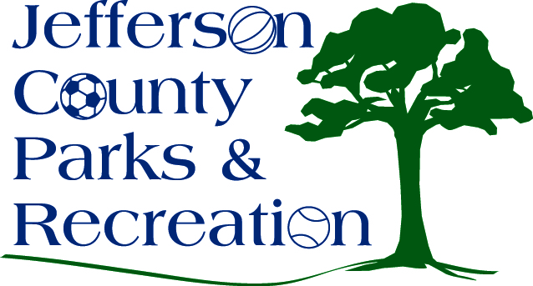
MINUTES
Jefferson County Parks & Recreation Commission
April 21, 2021
7:00 p.m.
Zoom

- Call to Order: 7:04 p.m.

- Roll Call: Compton, Hill, Manuel, Marshall. McIntyre, Milbourne, Mountz, Pierson, Taylor, Thompson

- Public Comment: none

- Approval of Minutes: Mountz made motion. Approved

- Treasurer’s Report: Treasurer Hill gave report

- Director’s Report: Director Myers gave the director’s report. As of April 1^{st,} all parks are open, and ballfields being used. Operating 100% capacity with social distance. Maintenance and mowing continue to be done on parks. Spring programs are underway and summer camps are filling up. Levitt Amp Summer Concerts starting June 10th. Some board members had a site visit to Riverside Farm. Motion to approved new hires by Taylor. Approved.

- Standing Committee Reports
      - Executive: met and discussed MOU with Riverside Park
      - Finance: no
      - Infrastructure: no
      - Operations: no
      - Audit: no

- Unfinished Business
  - Discussion and possible action on election of officers; Treasurer’s position
    - Motion by Manuel to elect Marshall as treasurer starting May 1st. Hill recused himself from voting.
- Old Business

- New Business
  - Discussion and possible action on approval of submitting a grant application in the amount of $10,000 to WV Culture and History for ADA Paths at the AMP.
    - Director Myers to submit grant application to WV Culture and History for $10,000 with matching money from Potomac Edison.

  - Discussion and possible action on approval of submitting a grant application to PlayCore, up to $65,000 for an inclusive playground at Sam Michael’s Park.
    - Mountz made motion to move $65,000 of impact fees to submit grant application to PlayCore for the playground at Sam Michael’s Park. Approved
  - Discussion and possible action on FY 21/22 Budget
    - Treasurer Hill Discussed
  - Discussion and possible action on naming of multi-purpose field to Ily Bratina Field.
    - Pierson gave the history of the Bratina family and how many years ago it was made known that the athletic field would be named after Ily Bratina but never happened. Hill made the motion to follow through with naming the field Ily Bratina field in honor of Ily Bratina. Approved.

- Adjourn: Taylor made motion to adjourn at 8:50 pm. Motion passed.

