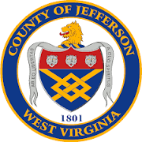

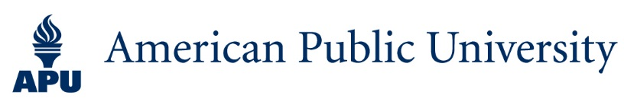

Jefferson County, WV and American Public University work together to provide you with affordable, career-relevant training and educational opportunities to help meet your professional development goals. APU courses are taught online in an asynchronous format, so you can learn on your schedule.

Key Benefits of this partnership are:
- 5% tuition grant
- Book grant: textbooks and/or ebooks are provided at no charge to students earning undergraduate academic credit
- Dedicated partnership admissions team.
Note: Grants cannot be applied retroactively

Please Click on the Links Below for more information:
- http://apuspartners.com/jeffersoncounty
- http://studyatapu.com/jeffersoncounty
- http://amuonline.com/jeffersoncounty

