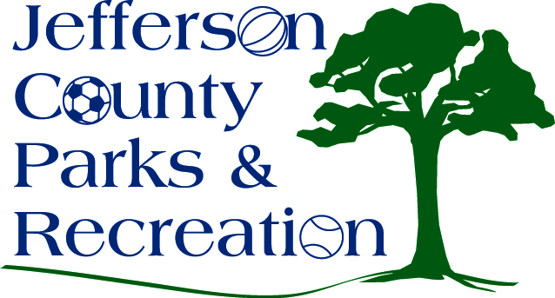
AGENDA
Jefferson County Parks & Recreation Commission
May 17, 2017
7:00 p.m.
Jefferson County Community Center

- Call to Order

- Roll Call

- Public Comment

- Approval of Minutes

- Treasurer’s Report

- Director’s Report

- Standing Committee Reports

      - Executive
      - Finance
      - Facilities/Land Acquisition
      - Fundraising
      - Audit

- Unfinished Business

- Old Business

  - Goose Hunting
  - Special Event Policy
  - MOU with Historic Landmarks

- New Business
  - 17-18 budget
  - Resolution for PetSafe grant
  - Letter of support for Steele Foundation Grant for Trailblazers Inc.
Start-up Proposal

