Purchase Card Statement Processing

Objective
This document illustrates the steps taken to process purchase card statements into accounts payable invoices.

Overview
After purchase card transactions have been imported, they are stored in Munis as purchase card statements. These statements are accessed using the Purchase Card Statements program, from which they are released to workflow for approval, and then converted to invoices.

Prerequisites
Before you can successfully use this feature, you must ensure that the necessary settings and codes are in place. If settings and codes are not set up, or not set up correctly, you may need to contact your Munis system administrator or department manager to have them updated or added into the Munis system.

- The purchase card import process must be completed in order to generate statements.
- In Accounts Payable Roles, you must be assigned the ability to view and maintain purchase cards, as well as convert purchase card statements to invoice on the Data Access tab of the Accounts Payable Roles program. The Allow Update of Purchase Card Transaction at or Below Status permission controls the statement status levels for which you can update a purchase card transaction (PCT) on a statement: New, Released, or Approved.

Procedure
To convert purchase card statements to invoices:
- Open the Purchase Card Statements program.
Financials > Accounts Payable > Invoice Processing > Purchase Cards > Purchase Card Statements
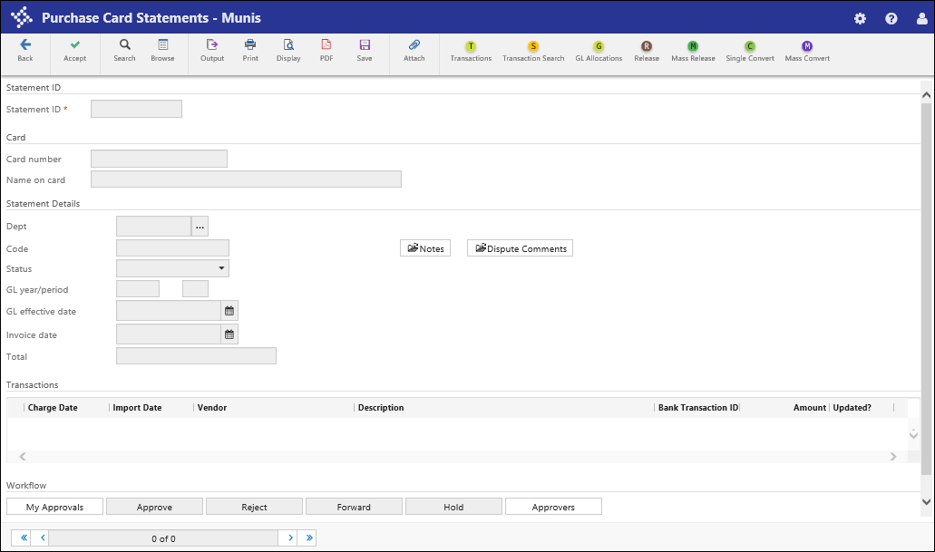
- Click Search to locate the purchase card statement to convert.
- On the toolbar, click Transactions to view the transactions that appear on the statement.
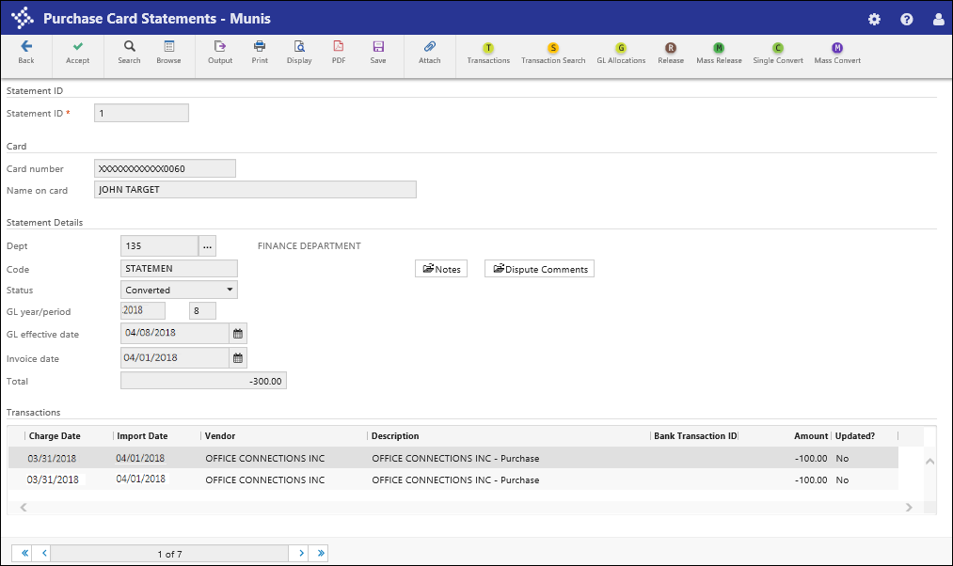
- Click Update.
- Change the Card Holder for Transaction, Vendor, Charge Description, Commodity Code, Contract, Work Order, Work Order Task, and allocation accounts as necessary.
- When you have finished making changes, click Accept.
- Use the navigation buttons to view additional transactions, making changes as needed.
- After you have finished updating the transactions, click Back to return to the Purchase Card Statements program screen.
- Click Release on the toolbar to release the statement to workflow.
The program applies the APC–AP Purchasing Cards business rule as defined by your organization. The statement must be approved before processing can continue.
If your organization does not make use of the APC business rule, the statement is automatically approved.
- After the statement has been approved, click Single Convert to convert the statement into one or more invoices. Alternatively, you can click Mass Convert to convert all the approved statements in the active set of records into invoices.
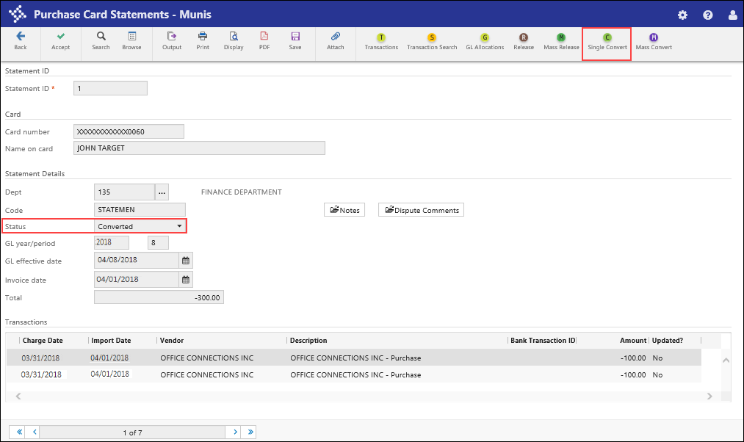
The program displays the Input GL Effective Date for Conversion dialog box.
- Enter an effective date for the journal entries that support the conversion and click OK.
The program performs the conversion and displays the Conversions Results screen, which lists the invoices generated and the transactions to which they apply. A single invoice is created for each vendor that appeared on the statement.

Results
You have converted a purchase order statement into one or more accounts payable invoices.

Status Change
The converted statements are updated with a status of Converted, and the invoices created by the conversion have a status of Hold.

GL Impact
When statements are converted to invoices, a journal entry is created for each allocation line on the transaction that is in a different fund than the purchase card liability account defined in Accounts Payable Settings. Once the journal is posted, the appropriate due to/due from entries are created.
When the purchase card invoices are posted, journal entries are created to credit the purchase card liability accounts and debit the expense accounts on the transactions.

What’s Next?
You must access the created journal entries and invoices and process them using your organization’s standard business practices.

