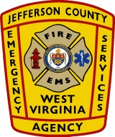

AGENDA CLASS II AMBULANCE FEE BUDGET HEARING
December 17, 2019

The Annual Class II Hearing for the Ambulance Fee Budget Hearing will be held at 6:30 p.m. on Tuesday December 17, 2019 at the JCESA Operations Center, located at 419 Sixteenth Avenue, Ranson, West Virginia 25438.

ROLL CALL Sign in Sheet

CALL TO ORDER

Director Keyser will present the Ambulance Fee Budget for fiscal year 2021. In addition, he will present fiscal year 2021’s proposed needs for staffing.

