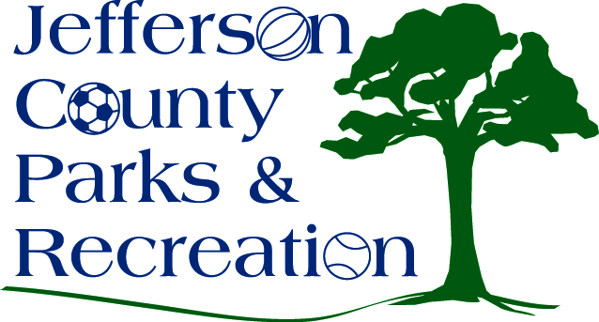
MINUTES
Jefferson County Parks & Recreation Commission
June 16, 2021
7:00 p.m.
JCCC, Sam Michael’s Park

- Call to Order: 7:00 p.m.

- Roll Call: Manuel, Marshall. McIntyre, Milbourne, Mountz, Pierson, Thompson, new liaison for JC Commission, Claire Ath

- Public Comment: none

- Approval of Minutes: Manuel made motion. Approved

- Treasurer’s Report: no

- Director’s Report: Director Myers gave the director’s report. Maintenance is under staff and trying to keep up with mowing at the parks. Some trees need to be cut at various parks. Levitt Amp Summer Concerts are underway. Summer programs are going on.

- Standing Committee Reports
      - Executive: no
      - Finance: no
      - Infrastructure: discussed multi sports field
      - Operations: no
      - Audit: no

- Unfinished Business

- Old Business

- New Business
  - Presentation by Patti Corley, Jefferson County Youth Board
    - Ms Corley presented Director Myers a check for $1000
  - Discussion and possible action on request to renovate tennis courts at Leetown Park for pickleball.
    - Discussed and Manuel made motion to check into renovating and setting up a times for pickleball. passed

  - Discussion and possible action on requesting American Rescue Plan monies from the Jefferson County Commission.
    - Discussed 2 recommendations-request for 1 million for engineering, planning, and consulting the sewer and septic system and 100 thousand in fracture for james Hite Park study.
  - Discussion and possible action on designating James Hite Park as a green park.
    - Discussed. Mountz made a motion to designate James Hite Park as a green park. Passed.
  - Discussion and possible action on adopting Design Build Institute of America (DBIA) best practices for collaborative delivery of our projects.
    - Marshall made motion to table until July meeting. Passed
  - Discussion and possible action on moving forward with an RFP for design and development of public sewer at Sam Michaels Park.
    - Discussed. Marshall made motion to move forward with an RFP for 30% design level and development of public sewer at Sam Michaels Park. passed
- Adjourn: Manuel made motion to adjourn at 8:26 pm. Motion passed.

