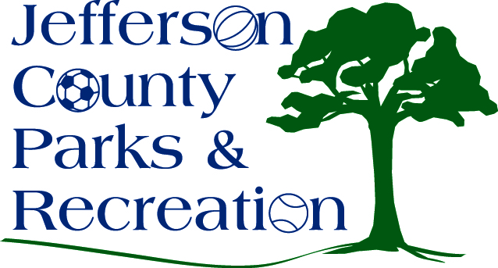
AGENDA
Jefferson County Parks & Recreation Commission
January 19, 2022
7:00 p.m.
Zoom: https://us02web.zoom.us/j/85217365378?pwd=RkUxdUdESGFJQjk1ak5Ga0YxZXM3dz09

- Call to Order

- Roll Call

- Public Comment: Please submit comments via email to jmyers@jcprc.org. Your
comments will be included in the minutes and agenda correspondence. Please remember
to include your name. You may also participate in public comment during the virtual
meeting by clicking on the link above and by raising your hand during the meeting.

- Approval of Minutes

- Treasurer’s Report

- Director’s Report

- Standing Committee Reports
      - Executive
      - Finance
      - Infrastructure
      - Operations
      - Audit

- Unfinished Business

- Old Business

- New Business

  - Discussion and possible action on Part-Time Salary Scale.
  - Discussion and possible action on County Commission Budget Request for FY 22/23.
  - Discussion and possible action on a Memorandum of Understanding with the City of Charles Town regarding programming and facilities.
  - Discussion and possible action on Easement with West Virginia Land Trust concerning Moulton Riverside Park.
  - Discussion and possible action on Letter of Intent/Support for the Chesapeake Conservancy to apply for an Economic Development Administration grant for a Moulton Park Master Plan.
- Adjournment

