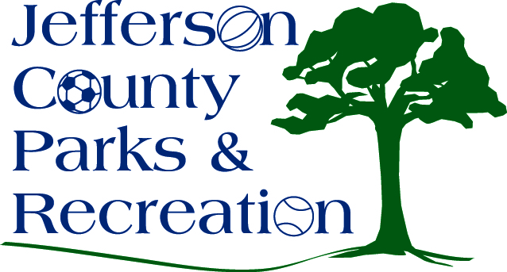
SPECIAL MEETING AGENDA
Jefferson County Parks & Recreation Commission
February 2, 2022
7:00 p.m.
Zoom: https://us02web.zoom.us/j/85217365378?pwd=RkUxdUdESGFJQjk1ak5Ga0YxZXM3dz09

- Call to Order

- Roll Call

- New Business

  - Work session to include discussion and possible action on Easement with West Virginia Land Trust concerning Moulton Riverside Park.

- Adjournment

