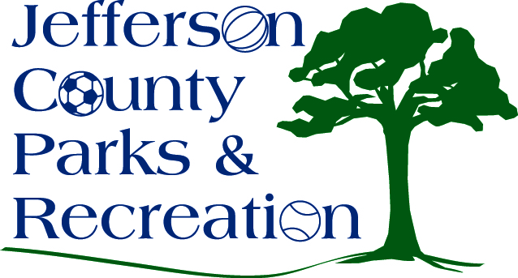
AGENDA
Jefferson County Parks & Recreation Commission
March 16, 2022
7:00 p.m.
JCCC
Jefferson County Parks & Recreation is inviting you to a scheduled Zoom meeting.
https://us02web.zoom.us/j/85217365378?pwd=RkUxdUdESGFJQjk1ak5Ga0YxZXM3dz09

- Call to Order

- Roll Call

- Public Comment:

- Approval of Minutes

- Treasurer’s Report

- Director’s Report

- Standing Committee Reports
      - Executive
      - Finance
      - Infrastructure
      - Operations
      - Audit

- Unfinished Business

- Old Business
  - Discussion and possible action on hybrid/in person meetings and equipment.
  - Discussion and possible action on maintenance plan/standards for parks and facilities.
  - Discussion and possible action on Riverside easement with West Virginia Land Trust.

- New Business
  - Discussion and possible action on update to Covid Reopening Plan and changes in policy.
  - Discussion and possible action on Full-Time Staff Salary Scale implementation. (Possible Executive Session)
- Adjournment

