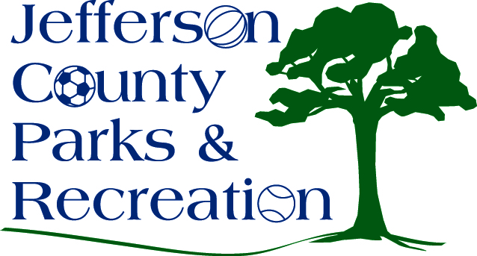
MINUTES
Jefferson County Parks & Recreation Commission
February 16, 2022
7:00 p.m.
Jefferson County Community Center

- Call to Order: 7:03 p.m.

- Roll Call: Baker, Benzinger, Manuel, Marshall, McIntyre, and Thompson

- Public Comment: none

- Approval of Minutes: Marshall made motion. Approved

- Treasurer’s Report: No report

- Director’s Report: Director Myers gave the director’s report. Maintenance work continues in the parks, winter programs are continuing, and park projects are starting.

- Standing Committee Reports
      - Executive: No
      - Finance: No
      - Infrastructure: No
      - Operations: Maintenance policy discussed
      - Audit: review no

- Unfinished Business

- Old Business
  - Discussion and possible action on Easement with West Virginia Land Trust concerning Moulton Riverside Park. (Possible Executive Session)
    - The Land Trust is making comments.

- New Business

  - Discussion and possible action on submittal of a WV Culture & History Grant for infrastructure related to phase II of the amphitheater.
    - Consensus from the board to more forward to submit the grant when it comes available.

  - Discussion and possible action on maintenance plan/standards for parks and facilities.
    - Review of the plan
  - Discussion and possible action on hybrid/in person meetings and equipment.
    - It was discussed to try to get better equipment to access meetings.
  - Discussion and possible action on hiring sound company for Levitt AMP Series.
    - It was discussed.

- Adjourn: Benzinger made motion to adjourn at 7:45 pm. Motion passed.

