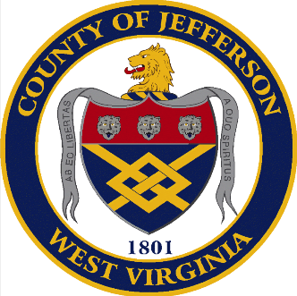
JEFFERSON COUNTY
VETERANS WALL OF HONOR
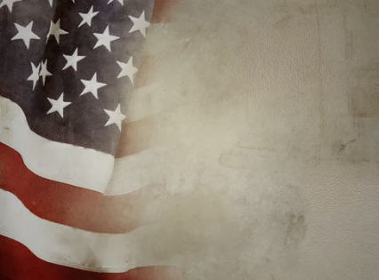
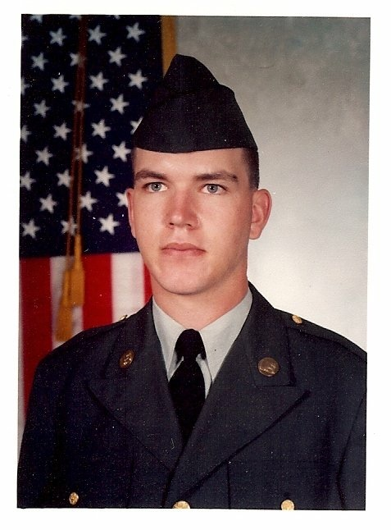

Tom Hansen
Army

Sheriff
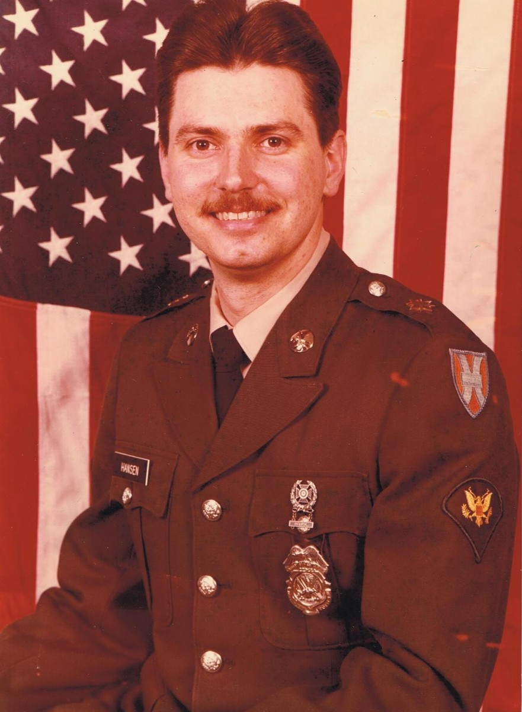
Kevin Carden
Army Reserve
1992-1998

Deputy County Clerk, Elections

Sheriff

Jeff Polczynski
Navy
1984-1988
Director of Communications
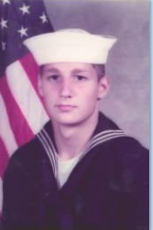
JEFFERSON COUNTY
VETERANS WALL OF HONOR

