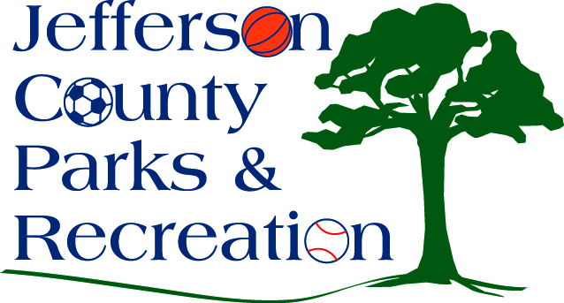
AGENDA
Jefferson County Parks & Recreation Commission
April 19, 2023
7:00 p.m.
https://us02web.zoom.us/j/87012308046
or Jefferson County Community Center

- Call to Order

- Roll Call

- Public Comment:

- Approval of Minutes

- Treasurer’s Report

Director’s Report

VII. Standing Committee Reports
1. Executive
2. Finance
3. Infrastructure
4. Operations
5. Audit
6. HR Committee

VIII. Unfinished Business
- Discussion and possible action on skate park at James Hite Park.

IX. Old Business

X. New Business

- Discussion and possible action on requiring helmets for girls
lacrosse. (Manuel)
2. Discussion and possible action on restructuring of park maintenance and hiring of park manager position.
2. Discussion and possible action on full-time employee health insurance plans.
3. Discussion and possible action on aquatic feasibility proposal and funding.
4. Discussion and possible action on request of a waiver from the Jefferson County Planning Commission to allow for groundwork and footers to begin before site plan for Phase II of the Amp is approved.

XI. Adjournment

