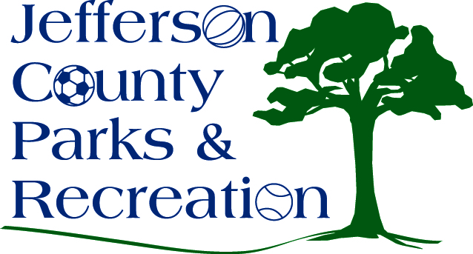
MINUTES
SPECIAL BOARD MEETING
Jefferson County Parks & Recreation Commission
March 8, 2023
7:00 p.m.
JCCC or Zoom

- Call to Order: 7:06 pm

- Roll Call: Allen, Baker, Benzinger, Manuel, Marshall, Milbourne, McIntyre, and Thompson

- Special Meeting Topics
      - Review, Discussion and Possible Action on fireworks contract for 2023 event to be held on July 1, 2023, at Sam Michaels Park.
        - Discussion. Director Myers stated that so far, the County Commission has agreed to give $10,000, The Town of Bolivar-$2500, and other towns are being asked to donation money toward the cost of the event. The board felt that they could get the rest of the funds needed. Allen made the motion to approve and sign the contract for the fireworks. Approved with Baker Abstaining.
      - Review, Discussion and possible Action on mowing contract for 2023 mowing season.
        - Discussion. The Operations Committee recommended to the board to award the 2023 mowing contract to Amazing Outdoors at $99,060 for 26 weeks. Allen made the motion to approve the Operations Committee’s recommendation to accept the bid from Amazing Outdoors at $99,060 with Allen reviewing the contract before signing. Approved with Baker abstaining.

- Adjournment: motion to adjourn at 7:47pm. Approved.

