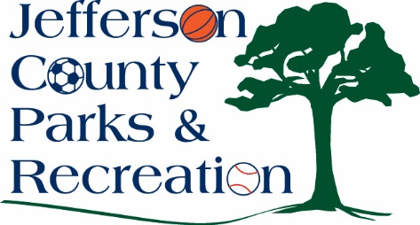
AGENDA
Jefferson County Parks & Recreation Commission
May 17, 2023
7:00 p.m.
https://us02web.zoom.us/j/87012308046
or Jefferson County Community Center

- Call to Order

- Roll Call

- Public Comment:

- Approval of Minutes

- Treasurer’s Report

Director’s Report

VII. Standing Committee Reports
1. Executive
2. Finance
3. Infrastructure
4. Operations
5. Human Resources
5. Audit

VIII. Unfinished Business
- Discussion and possible action on contract to complete an aquatic study.

IX. Old Business:
- Discussion and possible action on easement with WV Land Trust regarding Riverside (Moulton) Property.

X. New Business
1. Discussion and possible action on approval of FY 2023/2024 budget.

XI. Adjournment

