**AGENDA**

Jefferson County Parks & Recreation Commission

Special Meeting

August 30, 2023

6:30 p.m.

<https://us02web.zoom.us/j/87012308046>

or Jefferson County Community Center

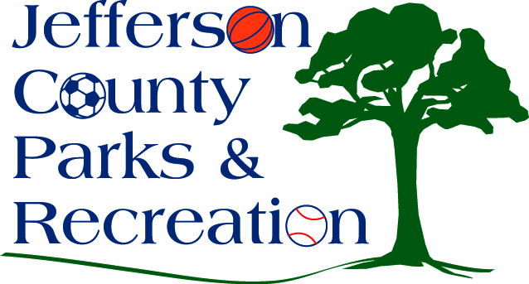

1. Discussion & possible action on announcement of a feasibility study for a YMCA to be constructed in Jefferson County and its potential impacts to parks & recreation.