**AGENDA**

Jefferson County Parks & Recreation Commission

October 18, 2023

7:00 p.m.

<https://us02web.zoom.us/j/87012308046>

or Jefferson County Community Center

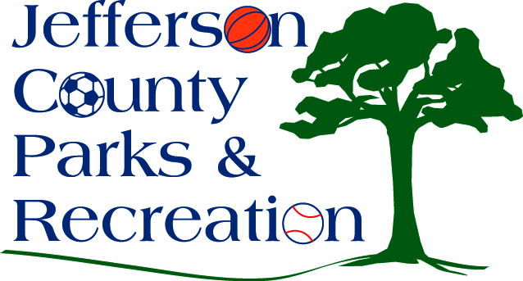

1. Call to Order
2. Roll Call
3. Public Comment:
4. Approval of Minutes
5. Treasurer’s Report
6. Director’s Report

VII. Standing Committee Reports

1. Executive

2. Finance

3. Infrastructure

4. Operations

5. Human Resources

6. Audit

VIII. Unfinished Business

IX. Old Business

X. New Business

1. Discussion and possible action regarding finance committee items to include discussion on signatory authority, treasurer’s reports, and financial processes.
2. Discussion and possible action to approve RFP for Moulton Park Comprehensive Plan.

XI. Adjournment