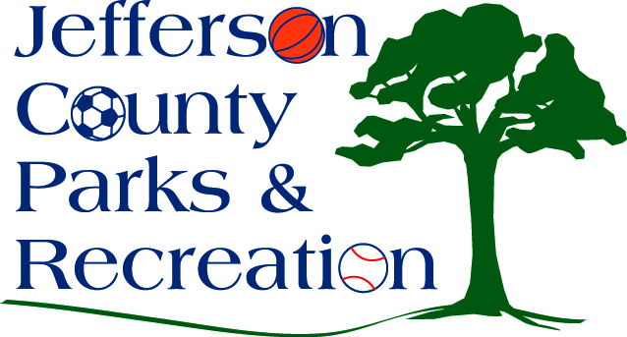
AGENDA
Jefferson County Parks & Recreation Commission
Finance Agenda
November 14, 2023
6:00 p.m.
JCCC or Zoom Link: https://us02web.zoom.us/j/81399597650?pwd=L0RUbDJYSkRHUWcvOGl1RHk3TE9FQT09

1. ACH Discussion with Bank of Charles Town.
2. Discussion of October Monthly Budget.
3. Discussion on Bill Payment/Payroll procedures.
4. Discussion of current accounting software/reporting.
4. Discussion of FY 22/23 Audit.

