**AGENDA**

Jefferson County Parks & Recreation Commission

November 15, 2023

7:00 p.m.

<https://us02web.zoom.us/j/87012308046>

or Jefferson County Community Center

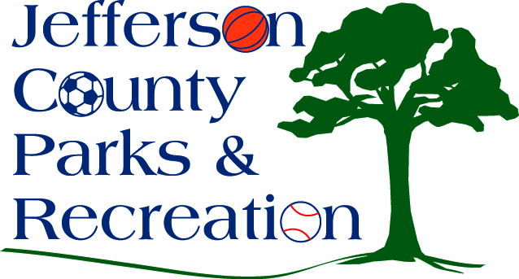

1. Call to Order
2. Roll Call
3. Public Comment:
4. Approval of Minutes
5. Treasurer’s Report
6. Director’s Report

VII. Standing Committee Reports

1. Executive

2. Finance

3. Infrastructure

4. Operations

5. Human Resources

6. Audit

VIII. Unfinished Business

IX. Old Business

X. New Business

1. Presentation on status of aquatic feasibility study.
2. Discussion and possible action on CIP submittal to the County Commission for FY 24/25.
3. Discussion and possible action regarding finance committee items to include ACH.
4. Discussion and possible action on memorandum of understanding with Charles Washington Orchestra regarding the AMP at Sam Michaels Park.
5. Discussion and possible action on memorandum of understanding with Charles Town Utility Board regarding construction of Phase II of the AMP.

XI. Adjournment