**AGENDA**

Jefferson County Parks & Recreation Commission

January 17, 2024

7:00 p.m.

Virtual link <https://us02web.zoom.us/j/87842521381?pwd=MW5IcHNqWjNnTEt1Y3lLb1BzQUJSZz09>

In person at Jefferson County Community Center,

Sam Michaels Park

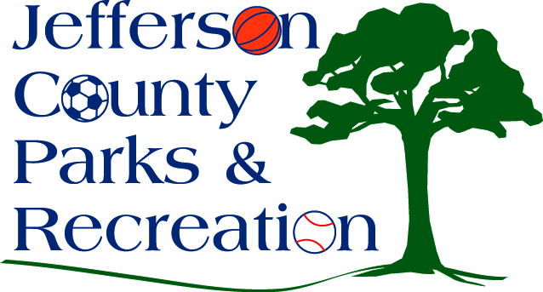

1. Call to Order
2. Roll Call
3. Public Comment:
4. Approval of Minutes
5. Treasurer’s Report
6. Director’s Report

VII. Standing Committee Reports

1. Executive

2. Finance

3. Infrastructure

4. Operations

5. Human Resources

6. Audit

IX. Old Business

X. New Business

1. Training by Kimberly Weber; WV Ethics Commission.
2. Discussion & possible action on letter of intent to apply for a grant through WV Culture & History for Edison lighting at the AMP.
3. Updates, discussion & possible action on Phase II construction of the AMP at Sam Michaels Park.
4. Discussion & possible action on 2024/2025 FY budget request to the Jefferson County Commission.
5. Discussion & possible action on first reading of bylaw changes to remove old business from the agenda.
6. Discussion and possible action on grant requirements and deed restrictions for Land & Water Conservation Funding.
7. Discussion and possible action on conveyance of land, within Charles Town City Limits; Parcel # 03 1013700000000 to the City of Charles Town.

XI. Adjournment