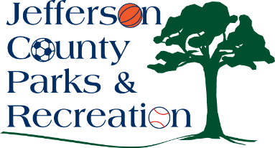
Jefferson County Parks and Recreation Commission
Finance Committee Meeting Agenda
February 13, 2024
6:00 p.m.
JCCC or via zoom:
https://us02web.zoom.us/j/84553483866?pwd=V2JPRWRBL0tTMUdaa1NUTy9Gd1ZSQT09

- Discussion on Internal Controls (Dana Fogle, CPA)
- 2023 State of Programs Report (Presented by Tommy & Heather)
- Update on 2023 Audit
- Review of January financials.
- Update on BCT ACH approval process.

