**AGENDA**

Jefferson County Parks & Recreation Commission

March 20, 2024

Virtual link <https://us02web.zoom.us/j/87842521381?pwd=MW5IcHNqWjNnTEt1Y3lLb1BzQUJSZz09>

In person at Jefferson County Community Center,

Sam Michaels Park

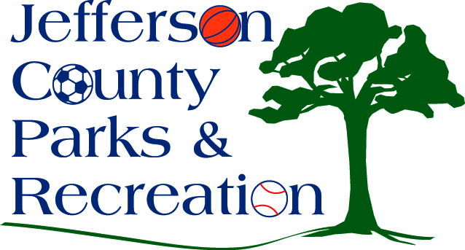

1. Call to Order
2. Roll Call
3. Public Comment
4. Approval of Minutes
5. Treasurer’s Report
6. Director’s Report

VII. Standing Committee Reports

1. Executive

2. Finance

3. Infrastructure

4. Operations

5. Human Resources

6. Audit

IX. Old Business



X. New Business

1. Discussion and possible action on approval of consultant for development of concept plan at Moulton Park.
2. Discussion and possible action on final draft of the aquatic study.
3. Discussion and possible action on public/private partnership to develop turf athletic fields in Jefferson County Parks.
4. Discussion and possible action on updating youth scholarship fund guidelines and forms.
5. Discussion/Updates on Jefferson County Commission FY 25 Budget and JCPRC allocation.
6. Discussion and possible action on bank transfer policy.

XI. Adjournment