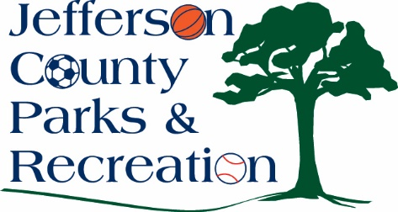
MINUTES
Jefferson County Parks & Recreation Commission
March 20, 2024
Virtual link https://us02web.zoom.us/j/87842521381?pwd=MW5IcHNqWjNnTEt1Y3lLb1BzQUJSZz09

In person at Jefferson County Community Center,
Sam Michaels Park

- Call to Order: 7:01

- Roll Call: Allen, Baker, Benzinger, Derrickson, Fields, Holland, McIntyre, Milbourne, Thompson

- Public Comment: none

- Approval of Minutes: Benzinger made a motion to approve. Approved.

- Treasurer’s Report: Treasurer Derrickson reported that the finances look good at the present time.

- Director’s Report: Director Myers gave the Director’s Report. All the parks are getting for spring by the maintenance department. New Playground is being installed at Sam Michaels Park. The dog park is shut down for a month to have maintenance work done to it. Rec Coordinator, Tommy presented Abbie with a certificate of appreciation for her service to the community.

VII. Standing Committee Reports
1. Executive: no
2. Finance: discussed the scholarship policy, and school levy
3. Infrastructure: discussed the aquatic study, concept for Moulton
4. Operations: no
5. Human Resources: no
6. Audit: no

IX. Old Business

The Handbook was discussed and will be brought back
Next month for approval
X. New Business

- Discussion and possible action on approval of consultant for development of concept plan at Moulton Park.
  - The infrastructure recommended to the board to go with Down Stream to be the consultant for Moulton Park. Allen made the motion to approve. Approve
- Discussion and possible action on final draft of the aquatic study.
  - The study was discussed, and Director Myers will report to the County Commission that the draft looks good
- Discussion and possible action on public/private partnership to develop turf athletic fields in Jefferson County Parks.
  - After discussion, the board will develop the fields and rent them out.
- Discussion and possible action on updating youth scholarship fund guidelines and forms.
  - Reviewed the scholarship fund guidelines and forms. Fields made the motion to approve the form with minor changes effective immediately. Approved
- Discussion/Updates on Jefferson County Commission FY 25
Budget and JCPRC allocation.
  - As of now, the County Commission has cut the funding that was requested.
- Discussion and possible action on bank transfer policy.
  - Derrickson made a motion to table the discussion. Approved

XI. Adjournment: Benzinger made a motion to adjourn at 9:06pm. Approved.

