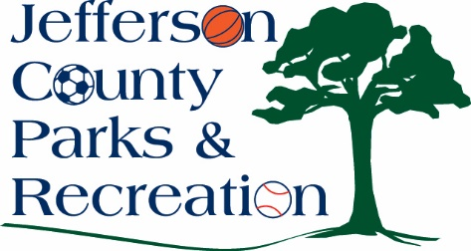
MINUTES
Jefferson County Parks & Recreation Commission
February 21, 2024
7:00 p.m.
https://us02web.zoom.us/j/87012308046
or Jefferson County Community Center

- Call to Order- 7:00pm

- Roll Call-Allen, Baker, Benzinger, Derrickson, Fields, Holland, McIntyre, Milbourne, Thompson

- Public Comment: Letter of support for alcohol for wedding at the columns

- Approval of Minutes: Allen made a motion to approve. Passed

- Treasurer’s Report: Treasurer Derrickson gave report

- Director’s Report: Director Myers gave report. Congratulations to Becky Zaglifa for 10 years! Josh Gibbs the new park superintendent introduced himself. Upcoming projects; Phase II of the AMP, playground construction, and dog park will be closed from 3/18-April 22 for maintenance. Summer planning is underway.
VII. Standing Committee Reports
1. Executive- no
2. Finance-met
3. Infrastructure-met
4. Operations-met
5. Human Resources-met
6. Audit-no

IX. Old Business

X. New Business

  - Discussion & possible action on approval of bid award for the 2024 mowing season.
    - Discussed. Holland made motion to go with Clear Vision’s Contract for the mowing season. Approved
- Discussion and possible action on approval of employee handbook.
  - Discussed and reviewed. Will bring back to board next month
- Discussion and possible action on bingo fundraiser for fireworks.
  - Milbourne discussed a fundraiser at Middleway Fire Hall on April 21 from 12:30-2:00
- Discussion and possible action on changes to the Easter Extravaganza event for 2024.
  - discussed

XI. Adjournment: Benzinger made motion to adjourn at 8:33pm

