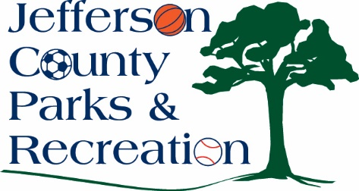
AGENDA
Jefferson County Parks & Recreation Commission
September 18, 2024
7:00 p.m.
JCCC
Sam Michaels Park or Virtual Link:
https://us02web.zoom.us/j/87842521381?pwd=MW5IcHNqWjNnTEt1Y3lLb1BzQUJSZz09

- Call to Order

- Roll Call

- Public Comment

- Approval of Minutes

- Treasurer’s Report

- Director’s Report

VII. Standing Committee Reports
1. Executive
2. Finance
3. Infrastructure
4. Operations
5. Human Resources
6. Audit

IX. Old Business

X. New Business
1. Election of Officers: President.
2. Discussion and possible action on approval of resolution to apply for a Land & Water Conservation Fund Grant in an amount up to $60,000 to build a small dog park at Sam Michaels Park.
3. Discussion and possible action regarding charging customers convenience fees for credit card purchases.
4. Discussion and possible action on FY 2024/2025 budget adjustments.
5. Discussion and possible action on re-classification of the mobile recreation coordinator position from a part-time to full-time position.
6. Discussion and possible action on reviewing a lease agreement and hiring a management company to manage the rental of the Riverside House, at Moulton Park. (Possible Executive Session)
7. Discussion and possible action regarding review of a land lease with Jefferson County Schools to build a park near Shepherdstown. (Possible Executive Session)
8. Discussion and possible action regarding the opportunity to purchase a parcel of land near Shepherdstown with Potomac River access. (Possible Executive Session)
9. Discussion and possible action on board orientation/park tour.

XI. Adjournment

