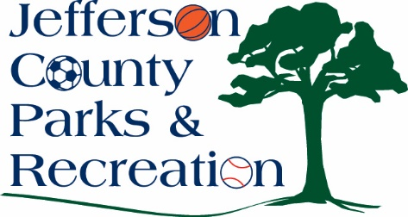
Jefferson County Parks & Recreation Commission
April 16, 2025
7:00 p.m.
JCCC
Sam Michaels Park, JCCC or Virtual Link:
https://us02web.zoom.us/j/88491859690?pwd=mO0iWnlwTegWXm6UMmu84xOw7fMYat.1

- Call to Order

- Roll Call

- Public Comment

- Approval of Minutes

- Treasurer’s Report

- Director’s Report

VII. Standing Committee Reports
1. Executive
2. Finance
3. Infrastructure
4. Operations
5. Human Resources
6. Audit

- Old Business

- New Business

  - Presentation from staff regarding summer programming opportunities.
  - Discussion and possible action on approval of RFP for development of a concept plan and construction documents for new 30-acre park, beside Shepherdstown Elementary School, near Route 230 and Flowing Springs Road.
  - Discussion on future open Commission positions and request to appoint a voting member from the Jefferson County Commission.

XI. Adjournment

