W.Va. state employees granted half-day for Good Friday

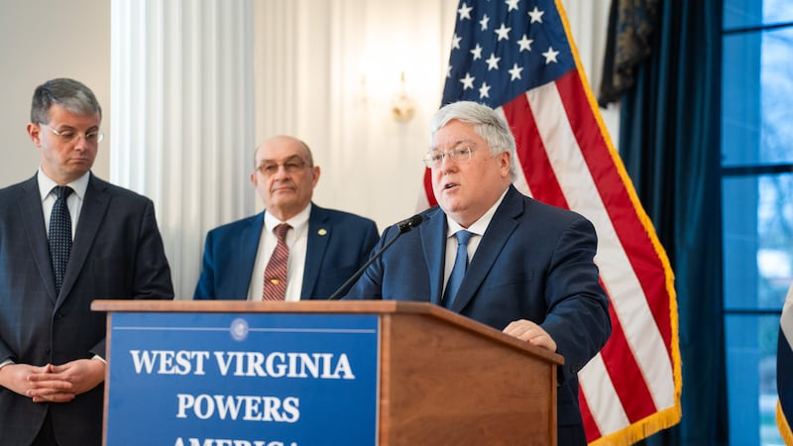

CHARLESTON, W.Va (WDTV) - West Virginia state employees will be excused for the second half of their work day this Friday, April 18, to observe Good Friday.
The announcement was made by Governor Patrick Morrisey Thursday afternoon.
“Good Friday is a day of reflection and prayer, and I am encouraging West Virginians to take time to be with their family and church community,” said Governor Morrisey.The proclamation applies to public employees in West Virginia and does not impact private businesses, local governments, or other individuals not employed by the state. It also excludes state employees who may be called upon to safeguard the health, safety, and welfare of West Virginia’s citizenry.

