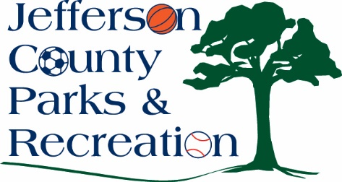
Jefferson County Parks & Recreation Commission
May 21, 2025
7:00 p.m.
Sam Michaels Park, AMP Conference Room or Virtual Link:
https://us02web.zoom.us/j/88491859690?pwd=mO0iWnlwTegWXm6UMmu84xOw7fMYat.1

- Call to Order

- Roll Call

- Public Comment

- Approval of Minutes

- Treasurer’s Report

- Director’s Report

VII. Standing Committee Reports
1. Executive
2. Finance
3. Infrastructure
4. Operations
5. Human Resources
6. Audit

- Old Business

- New Business

  - Presentation and discussion from Chris Broadway regarding development of a destination Skate Park in Jefferson County.
  - Discussion and possible action on FY 25/26 budget.
  - Discussion and possible action on approval to apply for a FY 25/26 Land & Water Conservation fund grant to expand the dog park at Sam Michaels Park; build a small dog park area and include features to help alleviate problems and concerns as well as help control access such as lighting, remote entry, and cameras.
  - Discussion and possible action to transition the fitness room in the Jefferson County Community Center to dance and classroom space.
  - Discussion and possible action to develop a disc golf course at Bolivar Nature Park.

XI. Adjournment

