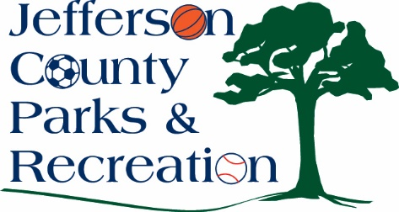
MINUTES
Jefferson County Parks & Recreation Commission
January 15, 2025
7:00 p.m.
JCCC
Sam Michaels Park or Virtual Link:

- Call to Order 7:01 pm

- Roll Call- Allen, Beaulieu, Derrickson, Dougherty, Fields, Holland, Jacot, McIntyre, Thompson, and Wilson.

- Public Comment-pickle ball
- Approval of Minutes-Wilson made a motion. Approved

- Treasurer’s Report-Treasurer Derrickson gave report. Wilson made a motion. Approved Motion by Wilson to approve Nov. & Dec. bills. Approved.

- Director’s Report -Director Myers reported on all the current projects in the parks. New hires. Holland made a motion. Approved

VII. Standing Committee Reports
1. Executive-yes
2. Finance- yes
3. Infrastructure-yes
4. Operations-no
5. Human Resources-yes
6. Audit-no
VIII. Old Business
IX. New Business
- Presentation, Discussion, and possible action on approval of concept plan for Moulton Park.
  - Discussed-board review
- Discussion and possible action on approval of bid to construct pickleball courts at James Hite Park.
  - Discussed-Wilson made motion to approve Lantz Construction for the project. Approved.

- Discussion and possible action on land lease agreement with Jefferson Conty Schools to construct a park at the Shepherdstown school property.
  - Discussion-Dougherty made motion review the ground use with JCS with the playground and have Executive Director to sign. Approved.
- Discussion and possible action concerning changes to the way JCPRC receives funding allocations from the Jefferson County Commission and the impact to budget and employees.
  - Discussed need more information from the County Commission.
- Discussion and possible action on FY 26 budget request to the Jefferson County Commission
  - discussed
- Discussion on election of officers-February meeting, 2025.
  - Discussed

XI. Adjournment- 9:18 p, m.

