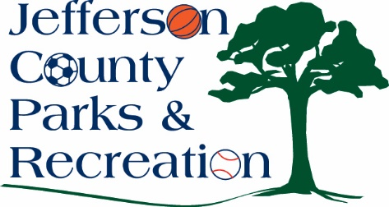
Jefferson County Parks & Recreation Commission
July 16, 2025
7:00 p.m.
Sam Michaels Park, AMP Conference Room or Virtual Link:
https://us02web.zoom.us/j/88491859690?pwd=mO0iWnlwTegWXm6UMmu84xOw7fMYat.1

- Call to Order

- Roll Call

- Public Comment

- Approval of Minutes

- Treasurer’s Report

- Director’s Report

VII. Standing Committee Reports
1. Executive
2. Finance
- Approval of June bills.
3. Infrastructure
4. Operations
5. Human Resources
6. Audit

- Old Business

- New Business
  - Discussion and possible action on approval of a resolution to authorize a line of credit at BCT, in the amount of $100,000.
  - Discussion and possible action on establishing an endowment fund or trust with Eastern West Virginia Community Foundation.
  - Discussion and possible action on updates to the Jefferson County Parks & Recreation Commission employee handbook.
  - Discussion and possible action on letter of support/commitment to apply for a Tap Grant for construction of ADA parking and recreational trail, along the river at Moulton Park.
  - Discussion and possible action to work with the WV Grant Resource Center.
  - Discussion on athletic field use policy updates.
  - Discussion and possible action on personnel issue. (Possible executive session).

XI. Adjournment

